[](http://aws.amazon.com/)

Amazon Web Services

Data Engineering Immersion Day

Real-Time Clickstream Anomaly Detection

Using Amazon Kinesis Data Analytics

Jun 2019

Table of Contents

Introduction 2

Set up an Analytics Pipeline Application 3

Connect Lambda as destination to Analytics Pipeline 9

Environment Cleanup 13

Appendix: Anomaly Detection Scripts 14

# Introduction

This guide helps you complete Real-Time Clickstream Anomaly Detection using Amazon Kinesis Data Analytics.

Analyzing web log traffic to gain insights that drive business decisions has historically been performed using batch processing.  Although effective, this approach results in delayed responses to emerging trends and user activities.  There are solutions that process data in real time using streaming and micro-batching technologies, but they can be complex to set up and maintain.  [Amazon Kinesis Data Analytics](https://aws.amazon.com/kinesis/analytics) is a managed service that makes it easy to identify and respond to changes in data behavior in real-time.

In the prelab, you set up the prerequisites required to complete this lab. Now, you will work to implement the following data pipeline .

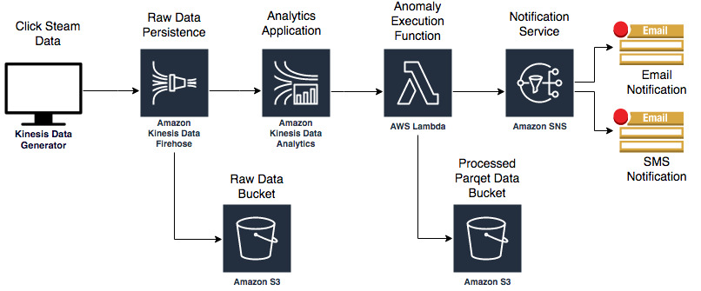

# Set up an Analytics Pipeline Application

**\*\*Make sure you are in US-WEST-2 (Oregon) region\*\***

1. Navigate to the **Amazon Kinesis** console**.**
2. Click **Get started** and then click **Create analytics application**.

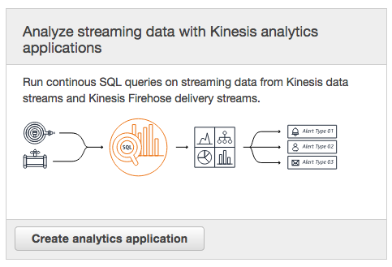

1. On the Create application page, fill the fields as follows:
   1. For **Application name**, type **anomaly-detection-application**.
   2. **F**or **Description, type a** description for your application.
   3. Leave “SQL” selected as Default.

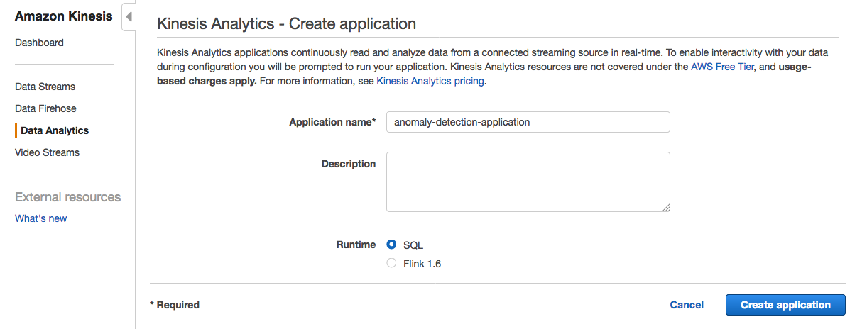

1. Click **Create application.**
2. On the application page, click **Connect streaming data**.

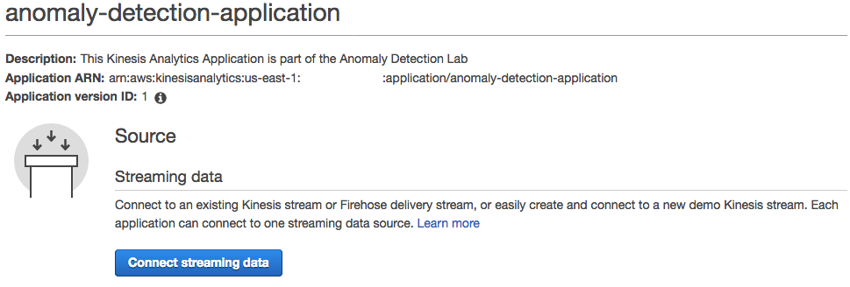

1. Select **Choose source**, and make the following selections:
   1. For **Source**, choose **Kinesis Firehose delivery stream**.
   2. For **Kinesis Firehose delivery stream**, type<stack name>-**FirehoseDeliveryStream**-<random string>

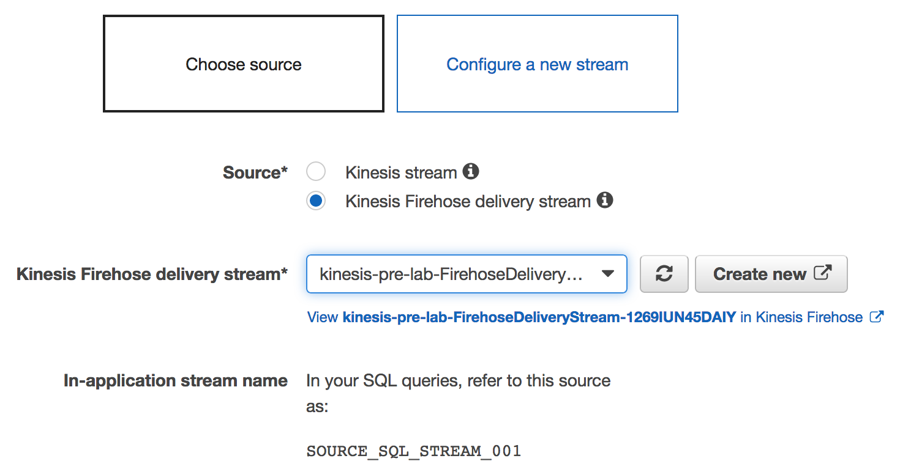

1. In the **Record pre-processing with AWS Lambda** section, choose **Disabled**.
2. In the **Access to chosen resources** section, select **Choose from IAM roles that Kinesis Analytics can assume.**
3. In the IAM role box, search for the following role:

<stack name>-**CSEKinesisAnalyticsRole**-<random string>

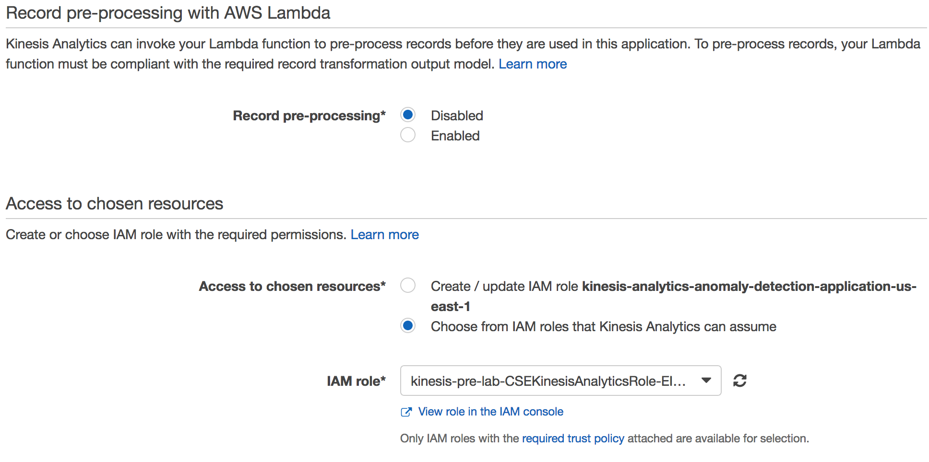

You have set up the Kinesis Data Analytics application to receive data from a Kinesis Data Firehose and to use an IAM role from the pre-lab. However, you need to start sending some data to the Kinesis Data Firehose before you click **Discover schema** in your application.

Navigate to the Amazon Kinesis Data Generator (Amazon KDG) which you setup in prelab and start sending the **Schema Discovery Payload** at **1 record per second** by click on Send data button. Make sure to select the region “us-west-2”

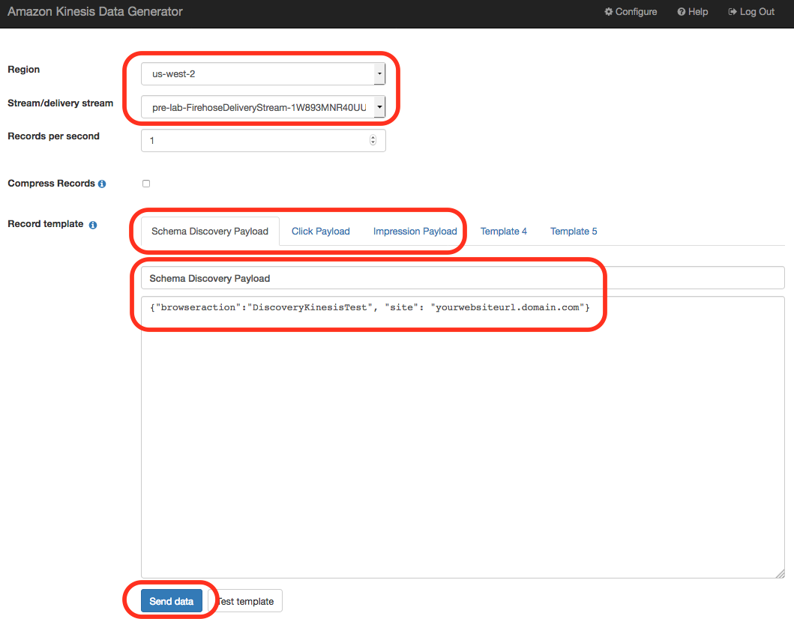

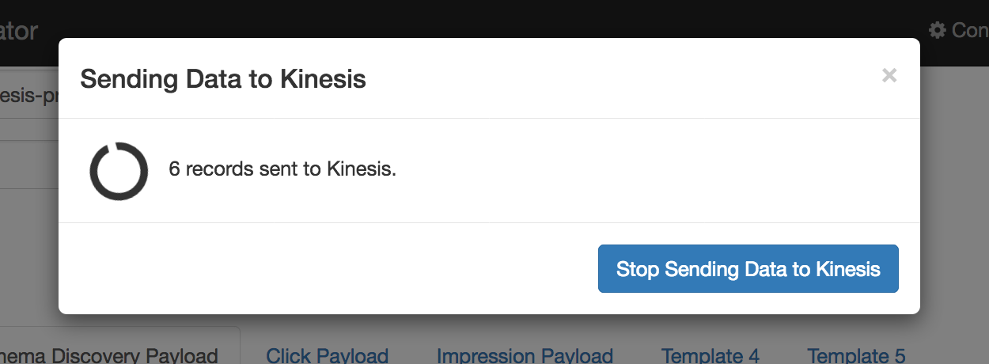

Now that your Kinesis Data Firehose is receiving data, you can continue configuring the Kinesis Data Analytics Application.

1. In the console?, click **Discover Schema**. (Make sure your KDG is sending data to your Kinesis Data Firehose.)

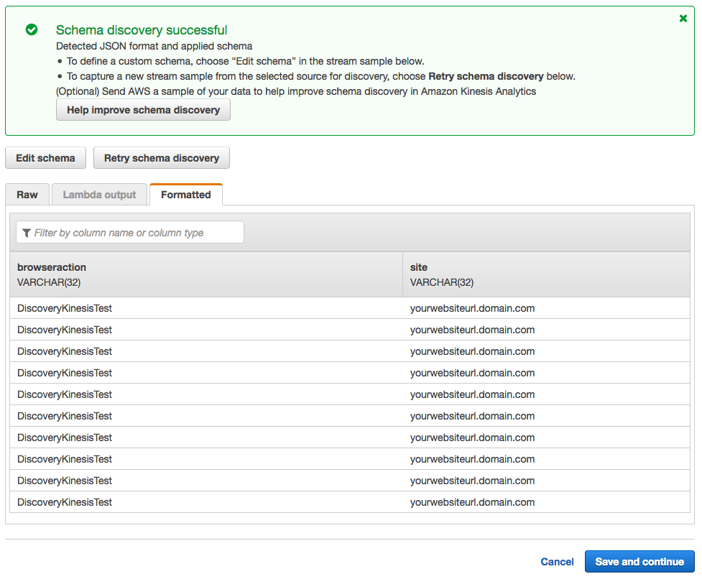

1. Click Save and continue. Your Kinesis Data Analytics Application is created with an input stream.

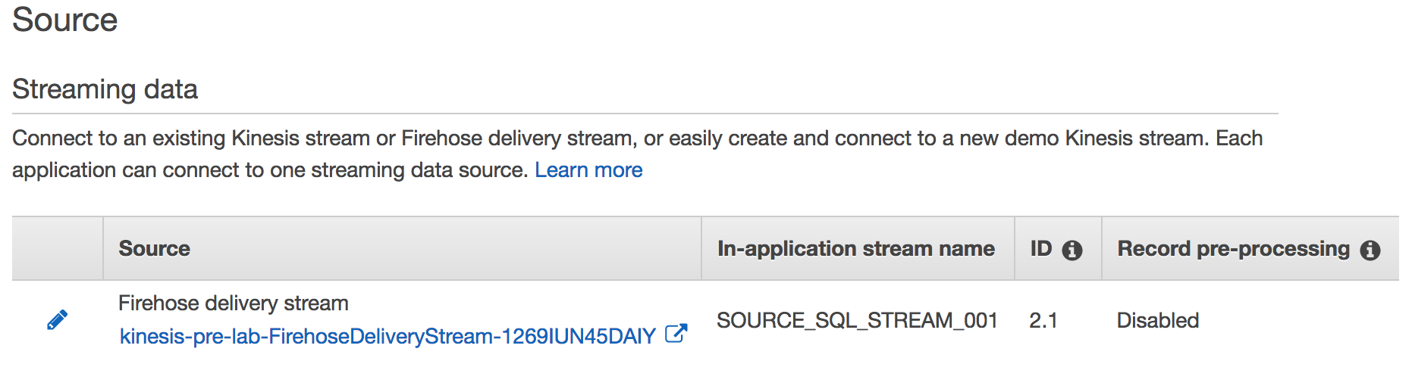

Now, you can add some SQL queries to easily analyze the data that is being fed into the stream.

1. In the **Real time analytics** section, click **Go to SQL editor**.
2. Click on **“Yes, start application”** to start your kinesis analytics application.

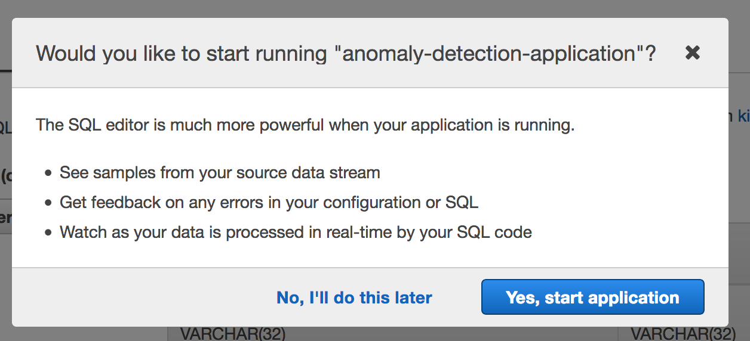

1. Copy the contents of the file named ‘**anomaly_detection.sql’** from your lab package and paste it into the SQL editor. (You can find code in Appendix)

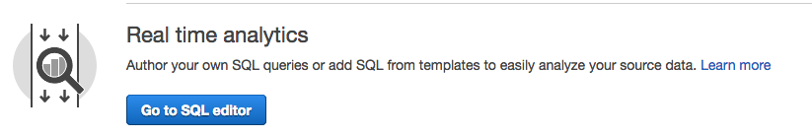

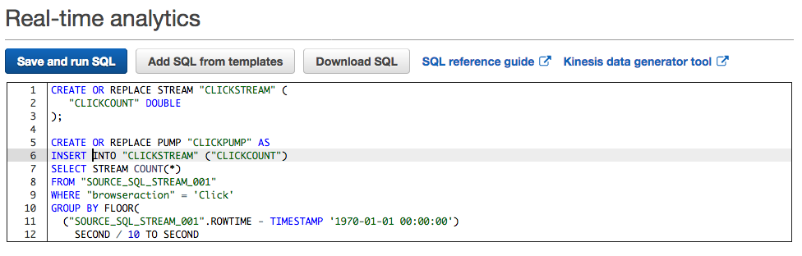

1. Click **Save and run SQL**. The analytics application starts and runs your SQL query. (You can find the SQL query in Appendix A.)

To learn more about the SQL logic, see the **Analytics application** section in the following blog post:

<https://aws.amazon.com/blogs/big-data/real-time-clickstream-anomaly-detection-with-amazon-kinesis-analytics/>

1. On the **Source data** tab, observe the input stream data named “SOURCE_SQL_STREAM_001”.

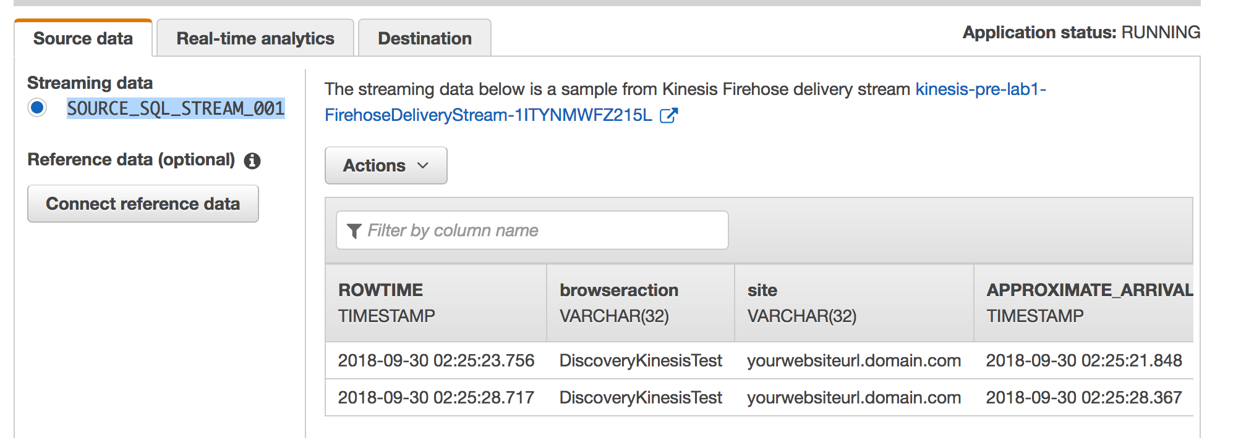

If you click the **Real-time analytics** tab, you will notice multiple in-application streams You will populate data in these streams later in the lab.

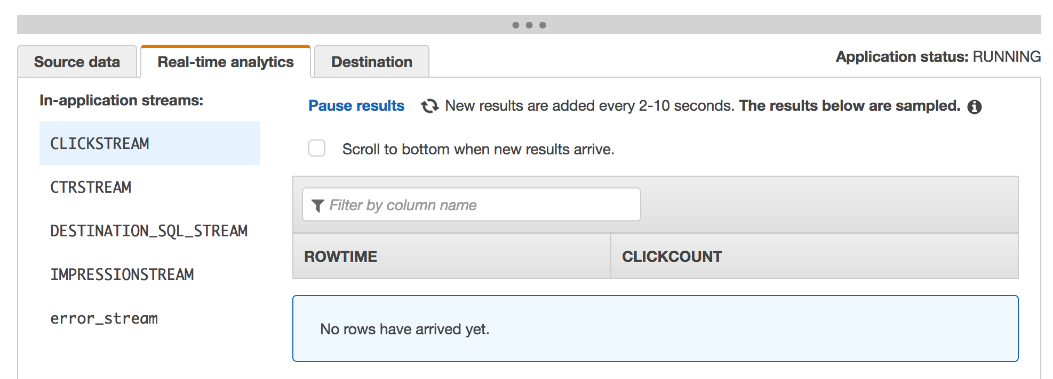

# Connect Lambda as destination to Analytics Pipeline

Now that the logic to detect anomalies is in the Kinesis Data Firehose, you must. connect it to a destination (AWS Lambda function) to notify you when there is an anomaly.

1. Click the **Destination** tab and click **Connect to a Destination**.
2. For **Destination**, choose **AWS Lambda function**.
3. In the Deliver records to AWS Lambda section, make the following selections:
   1. For **Lambda function**, choose **CSEBeconAnomalyResponse**.
   2. For **Lambda function version**, choose **$LATEST**.
4. In the **In-application stream** section, make the following selections:
   1. Select **Choose an existing in-application stream**.
   2. For **In-application stream name**, choose**DESTINATION_SQL_STREAM**
   3. For **Output format**, choose: **JSON**.
5. In the Access to chosen resources section, make the following selections:
   1. Select **Choose from IAM roles that Kinesis Analytics can assume**.
   2. For **IAM role**, choose **pre-lab-CSEKinesisAnalyticsRole-RANDOMSTRING**.

Your parameters should look like the following image. This configuration allows your Kinesis Data Analytics Application to invoke your anomaly Lambda function and notify you when any anomalies are detected.

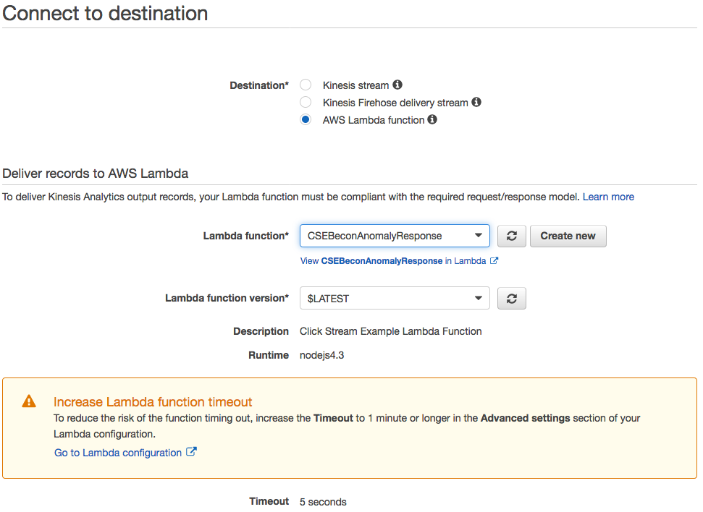

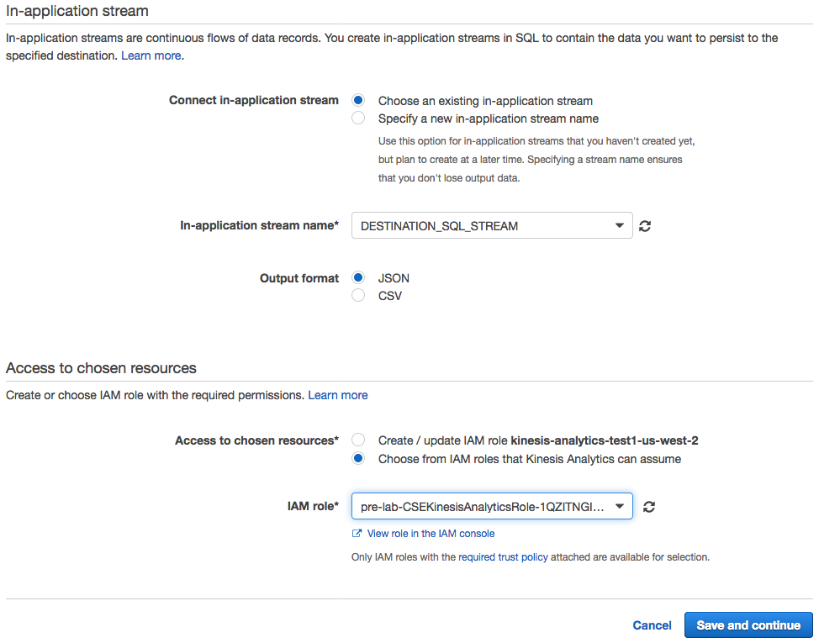

Now that all of the components are in place, you can test your analytics application.

For this part of the lab, you will need to use your Kinesis Data Generator in three separate browser windows. You need to replicate the clickstream data, and each browser window will send a different payload in each request to your Kinesis Data Firehose stream.

1. Open your KDG in five separate browser windows and sign in as the same user.

**Note:** Make sure to select the **us-west2** region. Do not accept the default region.

1. In one of your browser windows, start sending the **Impression** payload at a rate of 1 record per second **(keep this running)**.
2. On another browser window, start sending the **Click** payload at a rate of 1 record per second **(keep this running)**.
3. On your last three browser windows, start sending the **Click** payload at a rate of 1 record per second for a period of **20 seconds**.

**\*\*If you did not receive an anomaly email, open another KDG window and send additional concurrent Click payloads.** Make sure to not allow these functions to run for more than 10 to 20 seconds at a time. This could cause AWS Lambda to send you multiple emails due to the number of anomalies you are creating.

You can monitor anomalies on the **Real-time analytics** tab in the **DESTINATION_SQL_STREAM** table. If an anomaly is detected, it displays in that table.

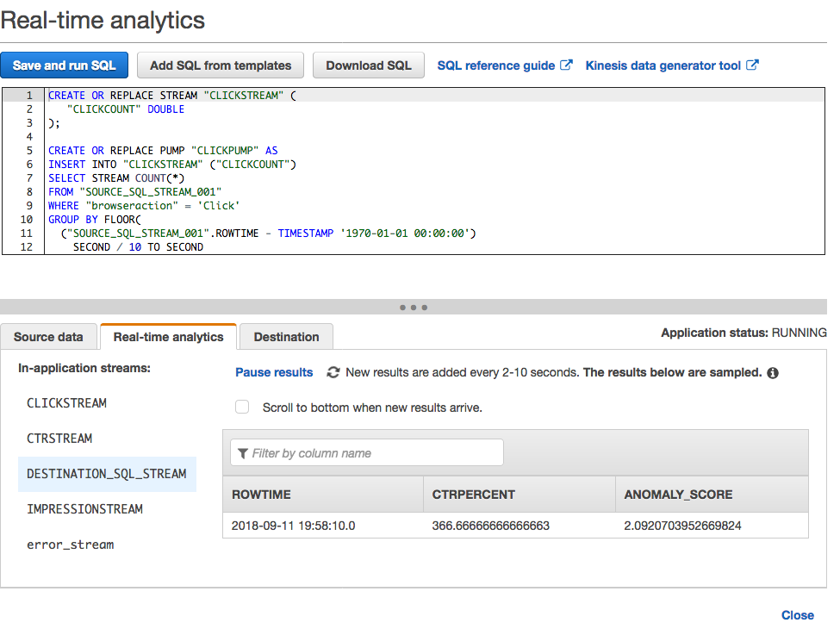

Make sure to click other streams and review the data.

Once an anomaly has been detected in your application and you will receive an email and text message to the specified accounts.

**Email Snapshot:**

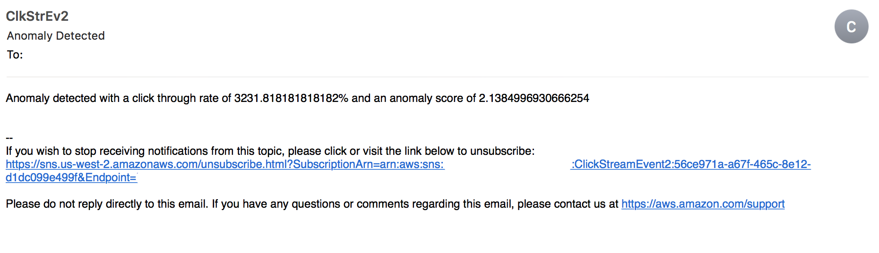

**SMS Snapshot:**

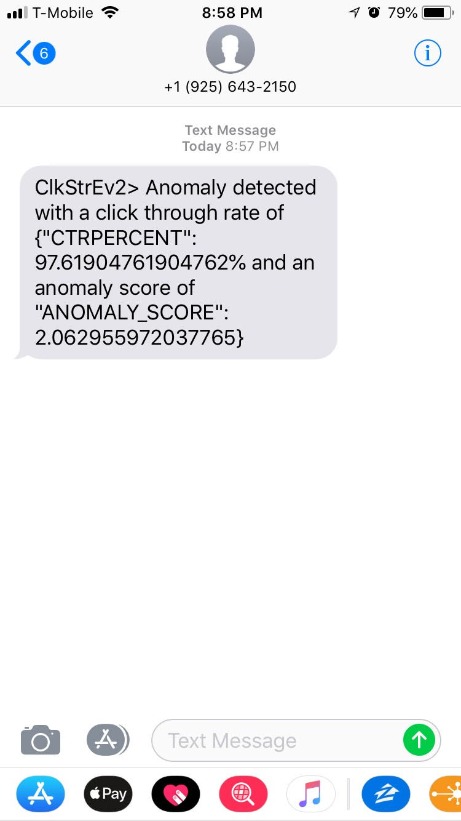

After you have completed the lab, click **Actions > Stop Application** to stop your application and avoid flood of SMS and e-mails messages.

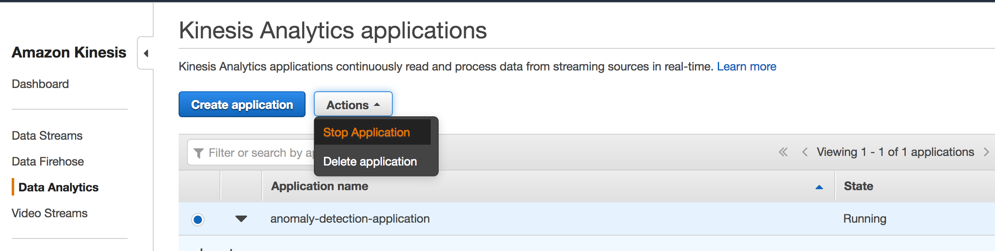

# Environment Cleanup

To save on cost, it is required to dispose your environment which you have created during this lab. Make sure to empty S3 buckets from console before following below steps:

1. In your AWS account, navigate to the **CloudFormation console**.
2. On the CloudFormation console, select stack which you have created during pre-lab.
3. Click on **Action** drop down and select delete stack as shown in below screenshot.

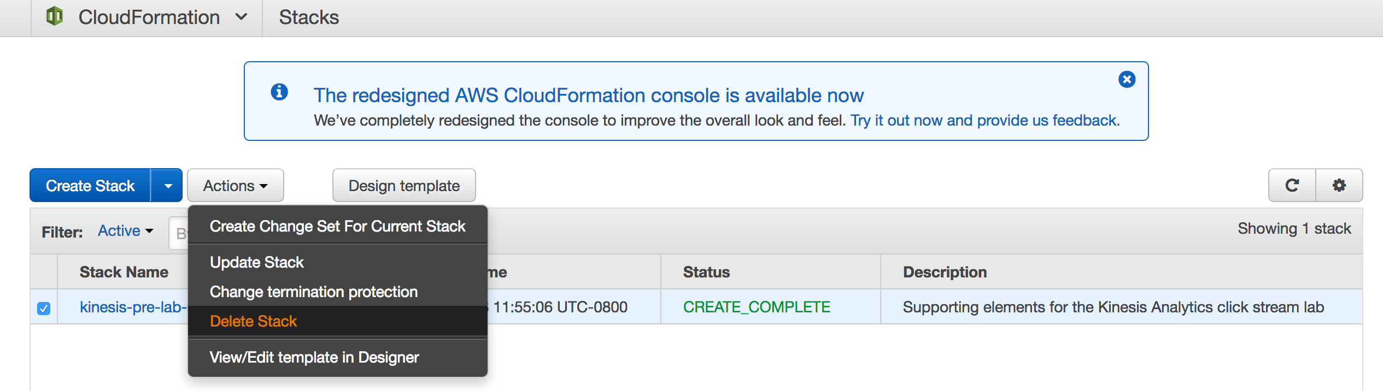

1. As you created, Kinesis Analytics application manually, so need to delete it by selecting your analytics application . Click on **Action** drop down and select delete application

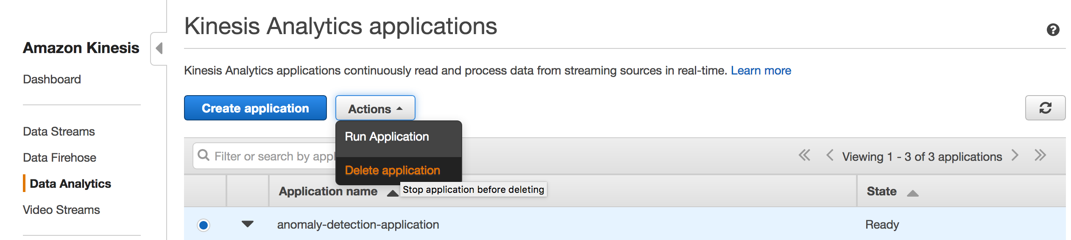

1. Go the Cognito and delete the user pool that have been created.

# Appendix: Anomaly Detection Scripts

**anomaly_detection.sql :**

CREATE OR REPLACE STREAM "CLICKSTREAM" (

"CLICKCOUNT" DOUBLE

);

CREATE OR REPLACE PUMP "CLICKPUMP" AS

INSERT INTO "CLICKSTREAM" ("CLICKCOUNT")

SELECT STREAM COUNT(*)

FROM "SOURCE_SQL_STREAM_001"

WHERE "browseraction" = 'Click'

GROUP BY FLOOR(

("SOURCE_SQL_STREAM_001".ROWTIME - TIMESTAMP '1970-01-01 00:00:00')

SECOND / 10 TO SECOND

);

CREATE OR REPLACE STREAM "IMPRESSIONSTREAM" (

"IMPRESSIONCOUNT" DOUBLE

);

CREATE OR REPLACE PUMP "IMPRESSIONPUMP" AS

INSERT INTO "IMPRESSIONSTREAM" ("IMPRESSIONCOUNT")

SELECT STREAM COUNT(*)

FROM "SOURCE_SQL_STREAM_001"

WHERE "browseraction" = 'Impression'

GROUP BY FLOOR(

("SOURCE_SQL_STREAM_001".ROWTIME - TIMESTAMP '1970-01-01 00:00:00')

SECOND / 10 TO SECOND

);

CREATE OR REPLACE STREAM "CTRSTREAM" (

"CTR" DOUBLE

);

CREATE OR REPLACE PUMP "CTRPUMP" AS

INSERT INTO "CTRSTREAM" ("CTR")

SELECT STREAM "CLICKCOUNT" / "IMPRESSIONCOUNT" * 100.000 as "CTR"

FROM "IMPRESSIONSTREAM",

"CLICKSTREAM"

WHERE "IMPRESSIONSTREAM".ROWTIME = "CLICKSTREAM".ROWTIME;

CREATE OR REPLACE STREAM "DESTINATION_SQL_STREAM" (

"CTRPERCENT" DOUBLE,

"ANOMALY_SCORE" DOUBLE

);

CREATE OR REPLACE PUMP "OUTPUT_PUMP" AS

INSERT INTO "DESTINATION_SQL_STREAM"

SELECT STREAM * FROM

TABLE (RANDOM_CUT_FOREST(

CURSOR(SELECT STREAM "CTR" FROM "CTRSTREAM"), --inputStream

100, --numberOfTrees (default)

12, --subSampleSize

100000, --timeDecay (default)

1) --shingleSize (default)

)

WHERE ANOMALY_SCORE > 2;